Fracking and Injection wells, do they cause earthquakes and why? This is what we asked ourselves when beginning this project. Prior to this class the majority of us never knew what fracking and injections wells are and how widespread they are. The uniqueness of our question comes from the ignorance of society and our generation around the environmental impacts of such things. We found a government report from 1987, that was about research done on injection wells and fracking in the 60s-80s, so if the government knew of that fracking caused so many issues how is it that people aren’t made aware of these issues. Even in advanced placement environmental science class fracking was never brought up even though it is very widespread and causes a lot of issues.

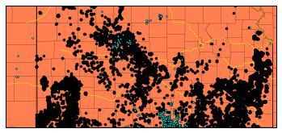On the topic of data and conclusions, there is an abundance of data on fracking, injection wells and other gas pump locations, earthquakes data is harder to find but is out there. We were able to find a database of a vast quantity of fracking, injection wells and gas pump locations in the United States, it contained information on the type of well, its latitude and longitude, the owner and state it was. It allowed us to form maps of the wells and overlay earthquake information on the maps. On this map of Kansas, the black dots are wells and the blue dots are major earthquakes of 3 or greater magnitudes. On the topic of earthquakes and fracking being related, there is a lot of debate online recently about the correlation between the two and there is a page on usgs.gov about induced earthquakes that explains most fracking wells are not the cause of induced earthquakes and it is instead injection wells. But a lot of these discussions and the usgs page does not correlate the issue directly to large increases in water pressure and the ability to mitigate the effects of the wells if we study the geological properties of the rock layers in the area. Through our research and the report Dillon found, we were able to infer that it would be feasible to have a government regulation that required a geological check of the rock layers to determine the amount of pressure allowed in well, so that we would be able to spread the various wells around so that we could reduce the risks caused by the wells. Also, we found that injection wells caused mainly micro-earthquakes of less than or around 1 magnitude. While not major, every earthquake gives a chance for a well to break and if we can reduce and minimize the earthquakes then we reduce well failure.

During our research Dillon found a paper report from the USGS from 1987 that talked about and explained deep well injection induced earthquakes, and the areas where induced earthquakes were prevalent [D2]. He also found a report by a geologist in Colorado about the Rocky Mountain Arsenal Disposal Well which was the disposal of dangerous leftovers from chemical warfare, which leaked into nearby groundwater which killed crops [D1]. The USGS report gave us detailed information on earthquakes in certain areas and the immediate increase in seismic activity after the instillation of injection wells in the areas. In the Colorado Rocky Mountain 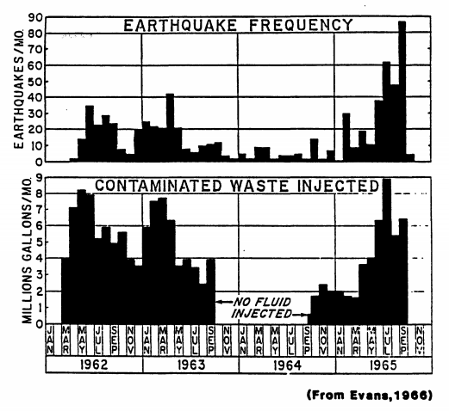Arsenal area, a total of 710 earthquakes were reported and a total of 620 million liters of water was injected into the well, increasing the fluid pressure in the area by a large amount. Through the research we found that it was often fluid pressure that was the defining factor in the cause of induced earthquakes. The USGS report detailed experiments done on some of the sites, one of which was the increasing and decreasing of fluid pressure in an area. It found that there were levels of fluid pressure that drastically increased seismicity and when low enough no earthquakes were detected in the area. The Mohr-Coulomb failure criterion, which is used to determine the strength and resilience of things such as rock formation, concrete and asphalt, could be determined the geological survey of the area at the bottom of the wells. This gives reason to our proposed government regulation that introduces geological surveying of areas around fracking and injection sites. A topic discussed in detail that we considered heavily was the Mohr-Coulomb theory, when looking over the earthquake reports we spoke of our idea of government regulation, and while looking through the rest of the paper we came to find that it also discussed a similar idea, of monitoring the strength of the rock formation around the well location and at the depth of the well, and to monitor fault lines and amount of friction. A usual earthquake occurs when the shear stress over comes the shear strength and frictional stress on a plane, which causes a slip or earthquake [D2]. When wells are drilled into the ground and rock layers it causes decreased shear strength which increases the chance of slips, with fluid pressure it causes a decrease of strength and increase on stress which is why injection cause far more earthquakes than with just fracking.

Citations

[D1] Evans, David M. “The Denver Area Earthquakes and the Rocky Mountain Arsenal Disposal Well.” *Engineering Seismology*, pp. 25–32., doi:10.1130/eng-case-8.25.

[D2] Wesson, Robert, and Craig Nicholson. “EARTHQUAKE HAZARD ASSOCIATED WITH DEEP WELL INJECTION.” *US Geological Survey*, June 1987.